# Environmental Logger Sensor Selections and Descriptions

Oct 7/16

## Pressure Sensor

This sensor will be used to measure the air pressure on Mars.

This sensor has an output voltage that varies linearly with pressure. The sensor will require a constant current circuit that is fed into the sensor. That will then need to be fed into an instrumentational amplifier to amplify the output voltage up to the 0 – 5V range that we can convert using the ADC on our board.

## Photodiode

This sensor will be used to measure the ambient light on Mars.

This sensor outputs a small current that varies linearly with light. This current can be put into a resistor and use (possibly several) inverting amplifier(s) to amplify the voltage to the 0 – 5V range that our board’s ADC can use as input.

## Thermistor

One potential option is NTC Thermistors. Data Sheet with temperature data and expected resistance found at: http://www.vishay.com/docs/29049/ntcle100.pdf

This temperature varying resistor will be used to measure the temperature on Mars.

This thermistor will need to be put into a voltage divider circuit in order to measure the voltage drop over it. It would be prudent to put this into a voltage follower buffer in order to ensure that the ADC does not accidentally mess up the results of the voltage divider giving us incorrect values and skewing our data. The following circuit would be what we would do to the circuit.

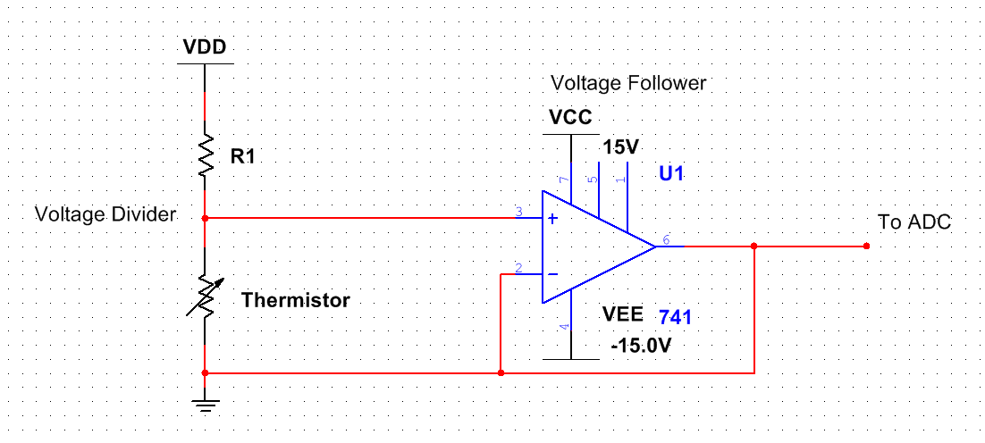

Figure : Thermistor Circuit

If supply voltage for the voltage divider is unable to provide a valid ADC voltage range the signal may need to be amplified by using two inverting amplifiers feeding into one another like the circuit shown below as Vs. This will likely not need the voltage follower in this case. The gain of this system will have to be calculated to work with the positive and negative rails of our ADC using the formula shown in Figure 3.

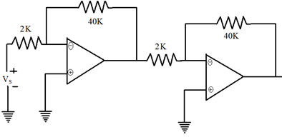

Figure : Cascading Inverting Amplifiers

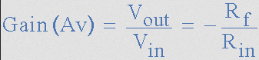

Figure : Inverting Amplifier Gain Formula

The actual code for turning these voltages into usable data will need a lookup table with the data found in the datasheet for getting temperatures from specific resistances.